Marketing Plan
Name
Instructor
Course
Date

I COMPANY DESCRIPTION
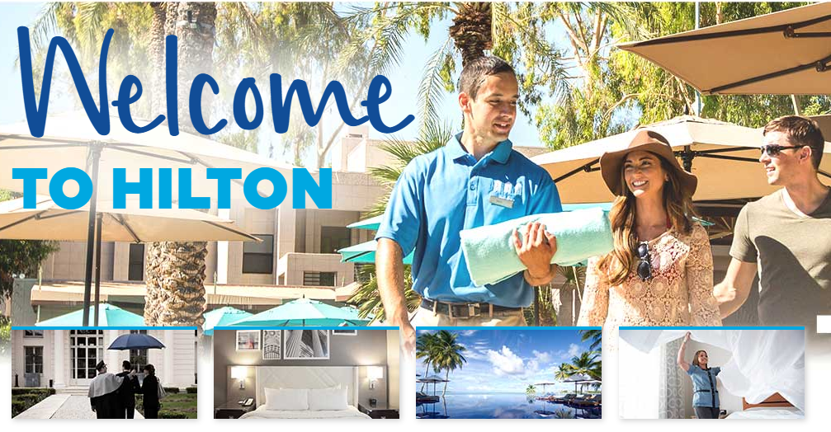

Hilton Worldwide Holdings have been in existence since 1919 with the capital of the hotel being in McLean, Virginia, United States. The hotel was established by Conrad Hilton. Currently, the Hilton Worldwide Holdings are located in more than 77 nations in the whole world. Now, there are 14 Hilton Hotel Brands each created to serve the particular needs of specific groups of travelers. The brands include: Conrad,Canopy, Curio, DoubleTree, Embassy Suites, Hampton Inn, Hilton, and Hilton Garden Inn. Hilton Hotel is the traditional brand under the family of Hilton that is most recognized worldwide. The motto of Hilton is that "travel should take you places."The hotel is open to open-minded travelers, weekend adventures and smart business people (Peter and Donnelly, 2011). The Conrad Hotels are developed particularly for luxurious travelers who are very specific about their accommodations as they are designed in a posh, contemporary, and elegant manner. Hilton Worldwide Holdings are hotels of choice for clients looking for a special place for special occasions like conferences, meetings; delicious or tasty meals at the hotel; drinks in the bar or lounge; a hotel room or an apartment. The DoubleTree is positioned as family-oriented, comfortable and affordable hotel mainly vacation travels. With restaurant and accommodation facilities, convenient hotel and versatile space, Spengler provide the clients with unique and particular special restaurant and hotel services and experiences. The tree is unique with interior designs with various types of rooms, suites, and banquet halls of different sizes including the "Grand Ballroom" which can carry more than 2000 guests for seminars, workshops, meetings, conferences, and other celebrations like weddings (Chen and Wang, 2010). Presently, the hotel has various hotels and resorts internationally. The hotel offers welcoming and restorative episodes and experiences in their multiple numbers of hotels in the whole world. Home 2 Suites hotel provides free internet services which operate at high speed, comfortable beds, and various restaurants and hotels choices that match the needs of their clients (Hollensen, 2015). The hotel strives to make their clients feel truly refreshed and restored, and get a home away from home especially when on a journey.
Hampton Inn provides commercial center, cultural attractions centers and easy access to the airport to their guests. With spacious and stylish rooms, the hotel offers both businesses as well as leisure of the clients who are on a journey, whether on short-period or long-period (Chen and Wang, 2010). Hilton Garden Inn offers services and comforts to their clients that meet the needs of the guests. The guests have a broad range of choices of drinks and food at the "Orchid Restaurant," the R Café and the 24-hours room services. Moreover, the hotel provides highly rated facilities and services such as free access to the hotel gym and hotel beach club, spa, and indoor swimming pool.

II BUSINESS MISSION

Discover our vision, mission, and values.
Since being founded in 1919, Hilton has been a leader in the hospitality industry. Today, Hilton remains a beacon of innovation, quality, and success. This continued leadership is the result of our staying true to our Vision, Mission, and Values.
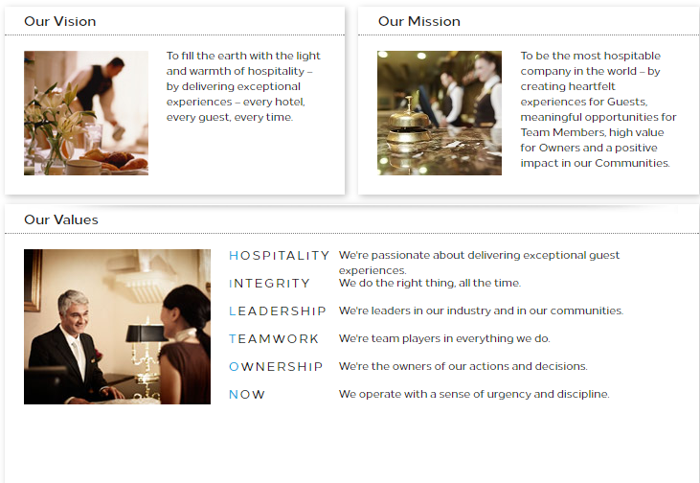
The motto of Hilton is that "travel should take you places." The hotel is open to open-minded travelers, weekend adventures, and smart business people. The hotels always to offer quality and fresh food truck in the Charlotte and quality services to their client at any time. Located in worldwide, Hilton Worldwide Holdings commit themselves to bringingfood truck in the Charlotte and quality services to the entire world. The motto of Homewood Suites brand is that "Make yourself at home." The purpose of the brand is to offer the guests with a home away from home with comfortable beds and hotel services
III SITUATION ANALYSIS
Industry Analysis
In order to provide a completeness and comprehensiveness of matters that may have a direct influence on the strategic position of the current business activities of the hotel, various analysis levels shall be offered to start with external factors (macro-environmental analysis) commonly known as PESTEL factors (Political, Economic Social, Technological and Legal factors ).
Political Factors
The decision was taken by the Government of the U.S.A under Obama’s administration to adopt the Free Trade Pact and trade agreements with Panama, Columbia, and South Korea will open markets for the firms of the United States of America, increasing exports and trade among the countries involved. This has enabled Hilton Worldwide Holdings to expand its operations and performance (Chen and Wang, 2010). The Free Trade Agreement has positively impacted on the U.S.A Tourist Industry that has resulted in around 33% of Panama, Columbia, and South Korea growth in the bookings of the hotels by the tourists visiting U.S.A.
Economic Factors
The U.S National Bank decided to do away with the minimum exchange rate during Obama era of 1.20Sf for one euro raising its value to about fourteen percent. This made the prices of various services in Swiss to be affordable (Kumar and Siddharthan, 2013). As a result, the U.S dollars become cheaper against other currencies and reports indicated that many tourists began to see the United States as an affordable holiday destination and therefore seeing a tremendous increase in the number of visitors in the United States of America. The hotel industry has expanded as a result of more tourists visiting the U.S.A.
Social Factors
The most significant social trends are represented by the new sharing economies which individuals are responsible for creating (Ryans, More, Barclay, and Deutscher, 2010). The old couples, as well as the millennial generation or individual tourists or travelers, are all searching for experience that is diverse that includes emotional edge as well as economic gain in sharing their stay according to a more personal travel-philosophy and intimate.The love of Americans for ecotourism has greatlypromoted the activities the hospitality industry. Therefore, Hilton Worldwide Holdings have created family holidays for the local tourists.
Technological Factors
Essential platforms that are internet-based have become more prominent, and their use has dramatically influenced the hotel industry in the United States (Peter and Donnelly, 2011). Among them, Airbnb emerged and increased the competition level within hotel industry in the U.S, and therefore would class hotels such as Hilton Worldwide Holdings has opted to specialize on offering high-quality services by applying the modern technology that has made the hotel to have a competitive edge over their rival hotels.
Ecological Factors
The U.S is considered a nation which mainly invests in her tourism sector in the winter period. The country is a snow-reliable with about 85% of the hotels making more returns during winter (Kumar and Siddharthan, 2013). Nevertheless, as a result of global warming and greenhouse effect has negatively influenced the tourism sector with reports indicating a decrease of six percent of the tourists in 2014/2015 winter season.
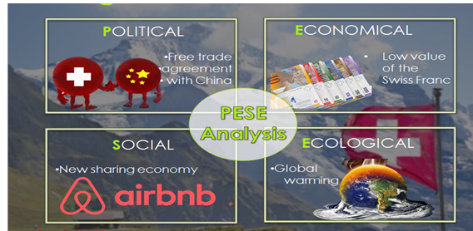
Porter’s Forces

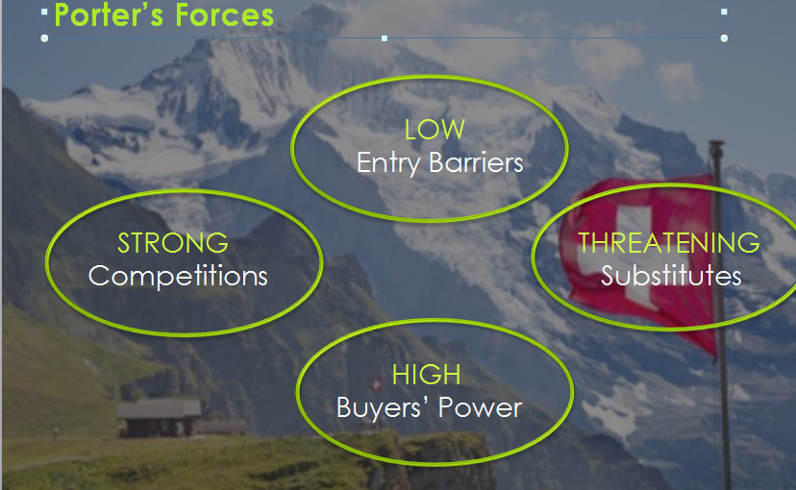

After analyzing essential components of the external environment have been outlined, it necessary to mainly focus on whether the hotel industry to which Hilton Worldwide Holdings operates can be considered as being attractive (Kumar and Siddharthan, 2013). This can be done through Porter Five Forces Analysis of 1979.
The first component which leads to the evaluation of the attractiveness is the entry barriers. The enormous expenses of financial funding, the needed legal requirements to build the hotel which match the dynamic and competitive hotel environment complicates the difficulty level to achieve the break-even point in the entry barriers in the U.S hotel sector (Chen and Wang, 2010). However, the stability of dollar enables the world hotels such as Hilton Worldwide Holdings to remain stable as the rate of inflation is also low. In addition to the macro factors, the economies of scale that hotels such as Hilton Worldwide Holdings also need to be interpreted as possible entry barriers as it could be possibly hard for new hotels to achieve greatness and the prosperity of well-established hotels.
Nevertheless, the hotel sector does not typically allow the successful and significant hotels to depend on their established prosperity to succeed (Kumar and Siddharthan, 2013). In the dynamic business world characterized with innovations and inventions, as well as new social trends for examples Airbnb trends already explained, even world class and five-star-hotels such as Hilton Worldwide Holdings needs to face the possible threats. These may be seen as substitute goods or services that explicitly in the mountainous areas may easily be as worth as the experience of the hotel (Hollensen, 2015). Individuals are for sure encouraged to save their cash particularly regarding long-term holidays where it may be more reliable to rent a room on ordinary agencies of the hotel or the Airbnb.
The buyers bargaining power is raised by the increase of the substitute products. Such is intended as both the agencies that develop a contract between the modern hotel and the clients and also the hotel's next guests (Peter and Donnelly, 2011). The selections of the visitors are increasing and meeting the new codes of the accommodation and desperately meet the travel experiences. Another factor that must be considered by theHilton Worldwide Holdings is the competitors of the hotel.
Hilton Worldwide Holdings is offering high-quality services that provide it with a competitive edge over its rival competitors. Not only are theHilton Worldwide Holdingsspread throughout the U.S, America and globally, but the Hilton Worldwide Holdings also have the best locations for the airport globally as compared to all the brands of the hotel internationally.

The Spengler Hotel Davos SWOT Analysis
Strengths
Customer Loyalty
With the wide variety of choices and selections in the Tourist and Hospitality Industry such as the Spengler Hotel Davos, IHG, Ramada and Premier Inn, Hilton Worldwide Holdings has created an excellent reputation for itself that has enabled the hotel to have loyal guests that believe and trust to the services offered by the hotel. Rather than targetting all the guests, theHilton Worldwide Holdings only requires aiming new guest to remain relevant as it grows and expand to acquire new markets.
Size Advantages
The advantages of the size lower the risks of theHilton Worldwide Holdings(Chen and Wang, 2010). The larger the Hilton Worldwide Holdings expands, the more the hotel gains economies of scale to acquire resources to be in a position to pursue the new global markets and compete favorably with the rival hotels.
Brand Name
Hilton Worldwide Holdings has an excellent international reputation with a strong brand name that makes the hotel to be outstanding in the Tourist and Hospitality Industry in the United States, North America and worldwide (Kumar and Siddharthan, 2013). This offersHilton Worldwide Holdingsthe ability to provide their services at high prices since the guests put additional value in the brand name.
Technology
Advanced and modern technology enables theHilton Worldwide Holdings to achieve the demands of the guests in better ways that their competitors cannot imitate.
Weaknesses
Cost Structure
A weak structure of the cost implies that Hilton Worldwide Holdings costs of the operations are high as compared to their competitors such as Spengler Hotel Davos, IHG, Ramada and Premier Inn.
Opportunities
New services
The new services assist Hilton Worldwide Holdings to meet the demands of the customers better than the competitors. The new facilities can help the Hotel to diversify the base of their clients and guests.
New Internal Technology
Modern and advanced technology enables the Hilton Worldwide Holdings to improve the needs and demands of the customers through strengthening their services and products. The contemporary technology also allows the Hilton Worldwide Holdings to build a competitive barrier against the competitors.
New Products
Development of a new service or product can assist the Hilton Worldwide Holdings to grow their hotel and to diversify the base of their customers and clients.
Threats
Intense Competition
Intense competition from world-class hotels such as Spengler Hotel Davos, IHG, Ramada and Premier Inn can lower the profits and returns of theHilton Worldwide Holdingssince the rivals can entice the guests away by offering them with superior services and goods.
Change in Tastes
The Tourist and Hospitality Industry is very dynamic that makes the guests and customers change their tastes and preferences more rapidly (Peter and Donnelly, 2011). The Hilton Worldwide Holdings rely on understanding the services and products that the clients and guests demand.
IV MARKETING OBJECTIVE
Competent, reliable, sustainable and reliable marketing started from a well-considered and informed marking decisions and strategies. A good marketing strategy assists the hotel in clearly outlining its core values, objectives, mission, goal, as well as business vision. The marketing objectives and goals of Hilton Worldwide Holdings describe the way the hotel is run to achieve the purposes, cores values, and aims defined by the management of the hotel. InHilton Worldwide Holdings, the marketing strategy is always planned and designed in the consultation of the team in research and development department in collaboration with the marketing department.

Hilton Hotels Business Strategy and Competitive Advantage

The backbone of Hilton Worldwide Holdings business strategy is service differentiation. Notably, the hotel differentiates its services based on the integration of the Information Technology, quality, and maintenance of the highest levels of standards into different service provision services.

One of the primary sources of competitive advantage of Hilton Worldwide Holdings is the digital hospitality. As shown below, the digitalization efforts of hotel relate to guest privacy and experience, data driven-personalization and loyalty, mobile services and booking channels. Furthermore, additional synergetic effects for the company are created by efficient digitalization integration.
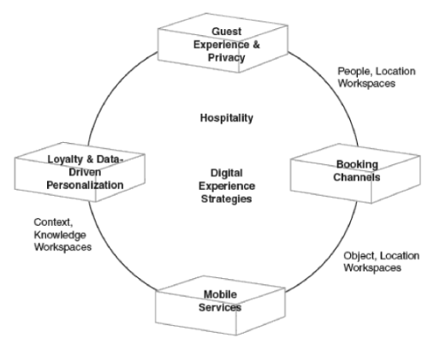
Hilton Hotels and Resorts digital experience strategies capabilities
The business strategy of Hilton Worldwide Holdings also depends on an extensive global expansion. By 2015, Hilton Worldwide added more than 100,000 rooms to its worldwide portfolios that included 14,500 independent hotels and brands from competitors.
V MARKETING STRATEGY
Product
The significant thing to note when choosing the dishes for the clients and guests is the fact that customers have a wide range of hotels to choose from (Peter and Donnelly, 2011). The guests have different ways and choices of spending the cash, and therefore quality would play an essential role in deciding the manner the clients spend their money. Thus, Hilton Worldwide Holdings put considerable attention on offering the dishes and meals that would satisfy the needs and demand of their clients. The hotel creates this through conducting market research and development. The hotel management comprehends that what is attractive, impressive and fashionable would be rendered useless with modern technology and globalization. The marketing and research and development of Hilton Worldwide Holdings, therefore, monitor the tastes and preferences of their clients to continue ensuring that the hotel offers their clients with what they exactly need or require. To be able to meet and satisfy the taste and preferences of the clients, Hilton Worldwide Holdings has introduced a diversified kind of menu and recipe and phased out outdated meals and dishes. The hotel shall continue doing so to make sure that they meet the needs of the guests and clients. After carrying market research, Hilton Worldwide Holdings would launch new meals and dishes on their menu.
No matter if a guest is searching for an apartment or hotel room in Hilton Worldwide Holdings, drinks in a lounge or bar, tasty and delicious meals at the restaurant, a special place for a special event such meetings, conferences, then Hilton Worldwide Holdings is a hotel of the choice. The hotel is very unique with prestige interior design that have several kinds of suites, banquet halls and rooms in various sizes that includes the Grand Ballroom that can accommodate up to two thousand guests for meetings, workshops, seminars and other ceremonies such as wedding. With other versatile and convenient hotel, accommodation and restaurant facilities, the hotel offers guests with certain special and unique hotel and restaurant experience and services.Currently, Hilton Worldwide Holdings has so many resorts and hotels globally.Hilton Worldwide Holdings provides a restorative and welcoming experience in their over a thousand hotels worldwide. The hotel offers comfy beds; a free internet service that is wireless and operates at very high speed and a variety of hotel and restaurants selections that fit the demands of their guests(Lichtenthaler2009). Hilton Worldwide Holdingsstrives in making their guests to feel truly restored and refreshed, and to feel at home while they are in a journey.
Hilton Worldwide Holdings offers easy access to the airport, cultural attractions, and commercial centers worldwide (Lichtenthaler 2009). With the stylish and spacious rooms, Hilton Worldwide Holdingscaters to both leisure and business of the guests who are travelling, whether on long-term stay or short time. The hotel provides modern comforts and services to their guests that match the demands of the customers (Esson 2011). The guests have a wide range of choice of food and drinks at the Orchid Restaurant, the twenty four-hour room service and R Café. Furthermore,Hilton Worldwide Holdingsoffers first-rate facilities such as indoor swimming pool, spa, and free access to the hotel beach club, and gym.
Place/Distribution
In the marketing mix, the term place does not merely mean the physical locations or distribution points for the goods or services. The site would consist the management range of processes that would involve availing services, meals, and dishes included in availing the services to final clients. From the survey of the potential consumers of the functions of the hotel, many consumers value quality than any other thing of the services offered by the hotel. Furthermore, many consumers regularly would come back to the hotel when his or her needs and demands are met. For those customers who not willing to reach the premises of the hotel can be offered with door to door services. The hotel is always ready and willing to deliver services and dishes at the doorsteps of the clients and guests.
Hilton Worldwide Holdings have over 5,000 locations in 100 territories and nations in the whole world. Hilton Worldwide Holdings have various branches all over the world with more unforgettable memories. Such includes Hilton Hotels & Resorts, Waldorf Astoria™ Hotels & Resorts, Conrad® Hotels & Resorts, Canopy by Hilton,Curio – A Collection By Hilton™,Doubletree By Hilton™, and Tapestry Collection By Hilton™. Worldwide Hilton Hotel Locations include Algeria, Argentina, Aruba, Australia, Austria, Azerbaijan,Bahamas, Barbados, Belgium, Brazil, Bulgaria, Cabo Verde, Cameroon, Canada, Chad, China, Colombia, Croatia, Curacao, Cyprus, Czech Republic, Ecuador, Egypt, Equatorial Guinea, Estonia, Ethiopia, Fiji, Finland, France, French Polynesia, Georgia, Germany, Greece, Guam, Honduras, Hungary, Iceland, India, Indonesia, Ireland, Israel, Italy, Jamaica, Japan, Jordan, Kazakhstan, Kenya,Kuwait, Lebanon, Malaysia, Malta, Mauritius, Mexico, Montenegro, Morocco, Myanmar, Namibia, Netherlands, New Caledonia (French), New Zealand, Nicaragua, Nigeria, Oman, Panama, Peru, Philippines, Poland, Portugal, Puerto Rico, Qatar, Romania, Russian Federation, Saudi Arabia, Seychelles, Singapore, South Africa,South Korea, Spain, Sri Lanka, Sweden, Switzerland, Thailand, Trinidad and Tobago, Turkey, U.A.E, USA, Ukraine, United Kingdom, Uzbekistan and Vietnam. Hilton Worldwide Holdings therefore serve a wide range of customers in different countries.
Promotion
Hilton Worldwide Holdings uses marketing mix promotions that would cover quality marketing and advertising strategies (Peter and Donnelly, 2011). The hotel offers 20% discount for the guests and clients who visit the premises of the hotel for more three times. Hilton Worldwide Holdings uses billboards, social media platforms, and digital marketing as some of form of modern advertising. Moreover, the hotel is socially responsible. Hilton Worldwide Holdings is often involved in voluntary activities that would assist the society in eliminating the production practices that would be hazardous to the community and the general public. The hotel has instituted hazard control programs which involve the steps of protecting the public from getting exposed to dangerous materials through the creation of public awareness as well as educating the public about the consequences of getting exposed to the hazardous substances. Hilton Worldwide Holdings has a safety inspection checklist to offers a guideline of the best practices to handle dangerous and dangerous materials as well as elements. The hotel always aligns with relevant institutions in creating a better environment to work and dwell in. Hilton Worldwide Holdings has set-up a foundation to help in public education and learning. This action has been viewed as a significant asset to the society the basis serves that has helped the hotel to develop a positive public image and profile. The hotel uses the internet and media distribution in exposing the possible dangerous or harmful activities it may be involved in. This has enabled the hotel to establish educational conversations with the public that has developed awareness of the social society. This common activism form has helped Spengler to reach the goals of social awareness and education. Hilton Worldwide Holdings has integrated social awareness strategy into management models that support it to monitor active adherence to social responsibility, applicable laws, business ethics, and standards.
The global sales team of Hilton Worldwide Holdings is consistently known as customer service and top selling focused company throughout the hotel and hospitality industry worldwide. Hilton Worldwide Holdings conduct businesses in more than 45 languages serving 25,000 clients in 100 nations from the offices suited around the world. This allowsHilton Worldwide Holdings to truly comprehend the unique opportunities and needs of regions worldwide, right down to the level of the local customers. Hilton Worldwide Holdings currently uses digital marketing as well as social media networks to gain competitive advantage over the its rival hotels in the hotel and hospitality industry.
Price
The perception of the clients and guests about value or quality of the dishes and meals is the primary determinant of the cost of the services offered by the hotel. The clients draw their picture of what the dishes and snacks worth (Peter and Donnelly, 2011). The hotel links the prices of the recipes and meals with the quality of services. The hotel usually avoids price penetration as a marketing tool that involves setting low rates that the competitors as the customer's views typically since the customers always feel that if the services are of little prices then they are still of low quality and the quality of such services are ever compromised. The Hilton Worldwide Holdings uses the competition based pricing strategy in addressing and responding to prices of the functions of the competitors. The hotel typically set the prices of its services either higher or lower depending on the competition levels as well as what the competitors do and how the hotel intends to position itself in the competition. Competition-based pricing is pricing that is established specifically to address and respond to them (Chen and Wang, 2010). The hotel also uses the skimming based pricing strategy especially when they offer services that have little competition. The hotel is always reluctant to use penetration based pricing strategy, but in case of stiff competitions, the hotel would opt for the penetration based pricing strategy to encourage the customers to try the balls and therefore capturing a significant share market share.
VI IMPLEMENTATION, EVALUATION, AND CONTROL
Marketing Research
With stiff competition that Hilton Worldwide Holdings is facing, it has been of great importance for the hotel to outdo its rival hotels and design unique identity and value proposition through strategic branding (Chen and Wang, 2010). While it has been important for Hilton Worldwide Holdings to offer high-quality meals and dishes, effective branding has been the heart of the hotel to strive. A good marketing strategy assists the hotel in clearly outlining its core values, objectives, mission, goal, as well as business vision. The marketing objectives and goals of Hilton Worldwide Holdings describe the way the hotel is run to achieve the purposes, cores values, and aims defined by the management of the hotel. InHilton Worldwide Holdings, the marketing strategy is always planned and designed in the consultation of the team in research and development department in collaboration with the marketing department.
Organizational Structure and Plan
The organization structure of Hilton Worldwide Holdings is comprehensive, detailed and hierarchal because of the enormous business size which comprises 13 brands that serve more than 140 million guests. Moreover, the organization structure of Hilton Worldwide Holdings may also be outlined as divisional, and the hotel has the following divisions:-
- Ownership division that comprises 146 hotels with about 59,463 rooms that are leased or owned by Hilton Worldwide Holdings
- Franchise and Management division with 4,419 hotels and 691,887 apartments.
- Timeshare division with 45 properties and 7,152 units.
Financial Plan
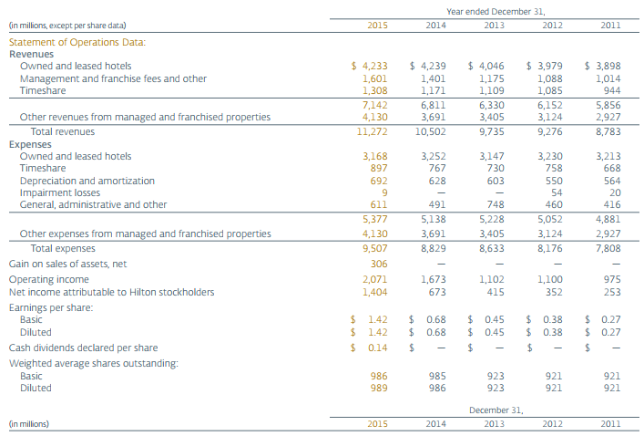
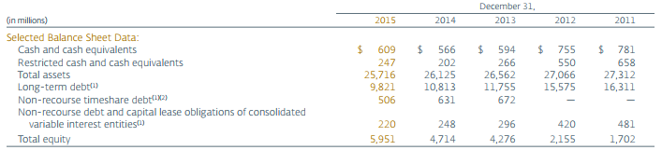
Implementation Timetable
Activity | Week 1 | Week 2 | Week 3-4 | Week 5 | Week 6 | Week 7-8 | Week 9-12
Development Of Company Description
Research of situation analysis of the hotel
Background research on SWOT Analysis
Determination and justification financial plan
Implementation, Evaluation, And control

VII SUMMARY
I realized that efficient, reliable, sustainable and reliable marketing starts from a well-considered and informed marketing decisions and strategies. A good marketing strategy starts with a defined core values, objectives, mission, goal, as well as business vision. I also learned that for the marketing plan to be successful the planning and designing of the plan must be conducted in the consultation of the team in research and development department in collaboration with the marketing department. The most interesting part of drawing the marketing plan is the SWOT analysis. The SWOT Analysis enables the team to identify the strengths, weaknesses, opportunities, and strengths. The SWOT analysis enables the company to establish a well-established marketing plan that is necessary for creating competitive edge or advantage in the dynamic and competitive hotel industry. With more time I would comprehensively analyze the financial statements in detail to establish the financial position, operations, and performance of the hotel. I would have calculated the financial ratios of the hotel to dig into detail the financial operations and performance of the hotel.

References
Chen, M. K., & Wang, S. C. (2010). The critical factors of success for information service industry in developing international market: Using analytic hierarchy process (AHP) approach. Expert Systems with Applications, 37(1), 694-704.
Hollensen, S. (2015). Marketing management: A relationship approach. Pearson Education.
Kumar, N., &Siddharthan, N. S. (2013). Technology, Market Structure, and Internationalization: Issues and Policies for Developing Countries. Routledge.
Peter, J. P., & Donnelly, J. H. (2011). Marketing management: knowledge and skills: text, analysis, cases, plans. Plano: Business pub., INC.
Ryans, A., More, R., Barclay, D., &Deutscher, T. (2010).Winning market leadership: Strategic market planning for technology-driven businesses.John Wiley & Sons.

